Practical 1

1. The data for this question is in file called practical1 (available in “Practical1” folder). This is a sample of 1,822 male workers from the UK in year 2020.

Variable Name | Description
pid | Person identifier
sex | Sex
jb_hrs | Hours worked (weekly)
age | Age in years
MnthLabInc | Earnings (monthly)
couple | Married/live with partner
wage | Hourly wage
lnw | Log Hourly wage
jb_ten | Tenure in current job
edu | The age the individual left full-time education
Age2 | Age squared
lon_se | Live in London or Southeast

- Run the following regression in Python
lnw=α+βedu+ε
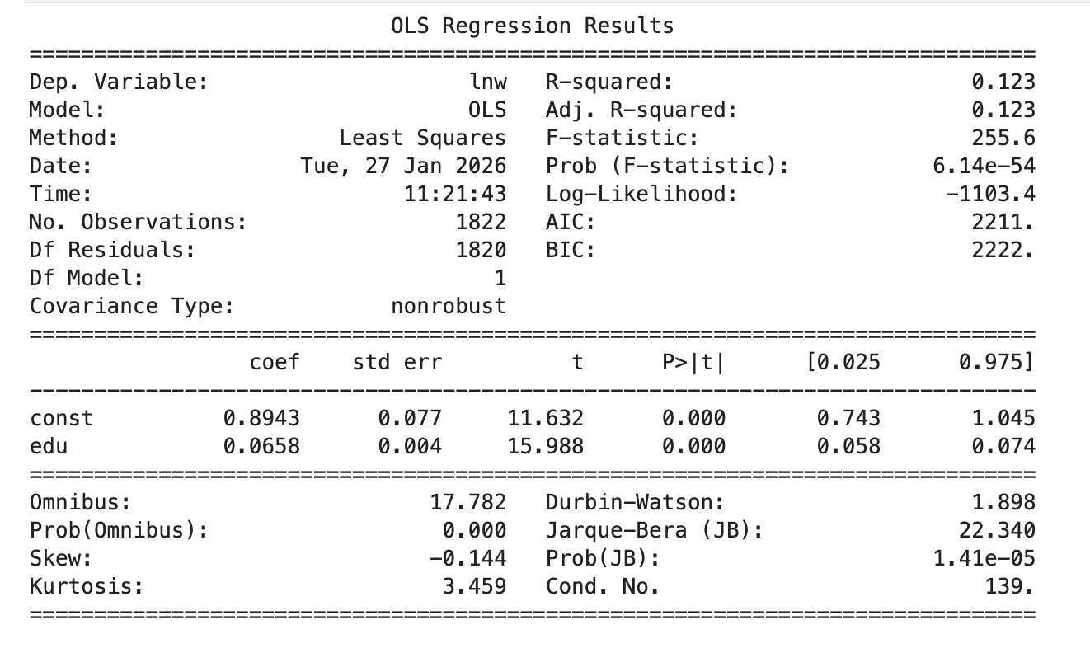
- What is the estimate of the constant 𝛼? What does the constant in this regression measure?
𝛼 = 0.8943
- What is the estimate of the parameter 𝛽? How would you interpret this parameter?
𝛽 = 0.0658

2. You have data from an extensive medical survey on health and economic status. A cross-section of 1000 men provides information on wages in £ per week, age in years a and an index of fitness f.
You run the following regression of ln wages on the fitness index:
lnw = 6.1+0.08f+𝜀̂ (1)

- Interpret the coefficient of fitness. Why Economists usually use ln wage instead of wage as dependent variable. Explain your answer.
For every 1 additional unit increase in Fitness, there will be an 8% increase in wages. Economist usually use ln wage because it directly gives percentage changes of the dependent variable.

Or

Ln Wage is predicted to increase by 0.08 for every additional unit of Fitness

You then add age to the regression with the following results:
lnw =5.3+0.07a+0.12f+ 𝜀̂ ‘ (2)

- Explain carefully why and how adding age to the regression can change the size of the estimated fitness effect. Do the results indicate that age must be negatively or positively correlated with fitness in this sample?
When age is added, the residual changes as it no longer considers age as a disturbance in it. Now, age is another independent variable that affects ln w.
𝜀̂ = 0.07a + u
𝜀̂’ = u
Hence the size of the estimated fitness change would change. It depends on 2 things, Cov (a,f) and 𝛽 for age (0.07) / fitness (0.12).
Previously 𝛽 for fitness is 0.08 and now its 0.12 hence there was an underestimation in the previous model. Combining with the info that 𝛽 for age is >0. Hence it can be concluded Cov (a,f) is < 0.

